1. In annual ops tab if I am selecting GT3 and disabling GT1 and GT2 and shifting to OIF Profile Tab the marker is not pointing to GT3 so the header marker is on GT1

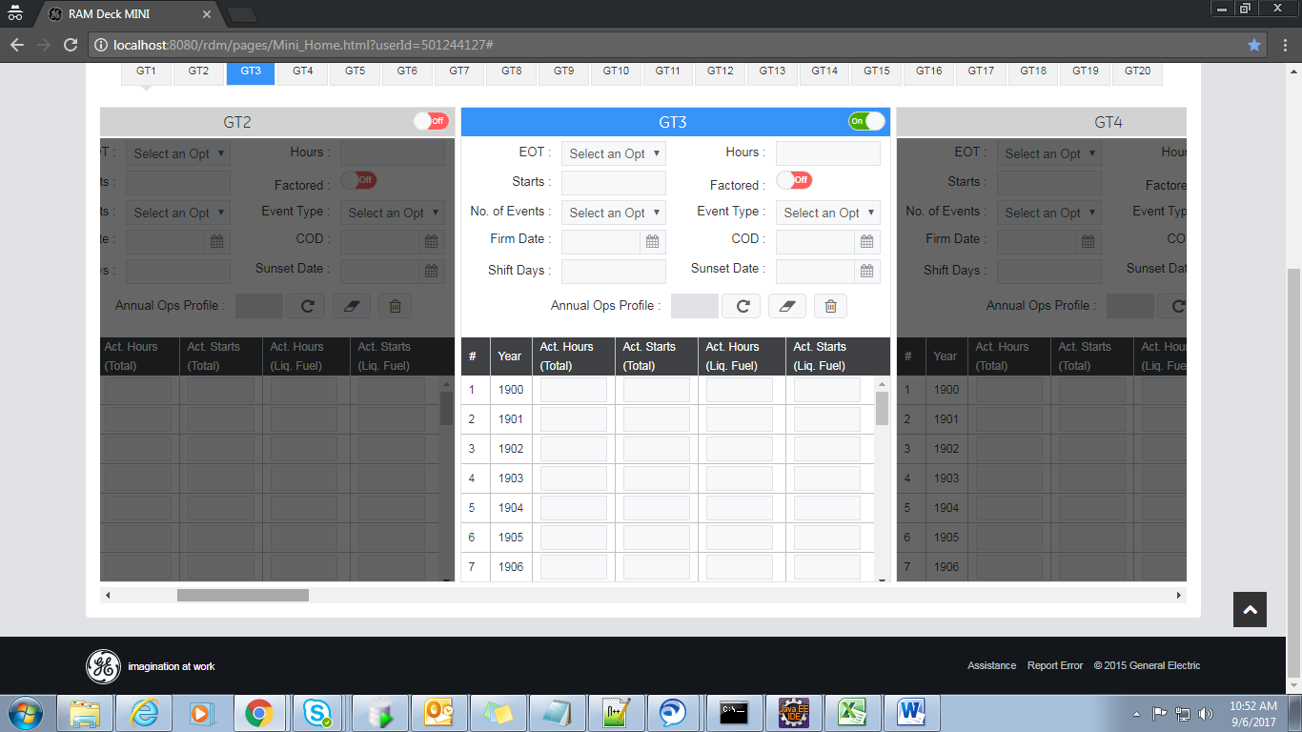

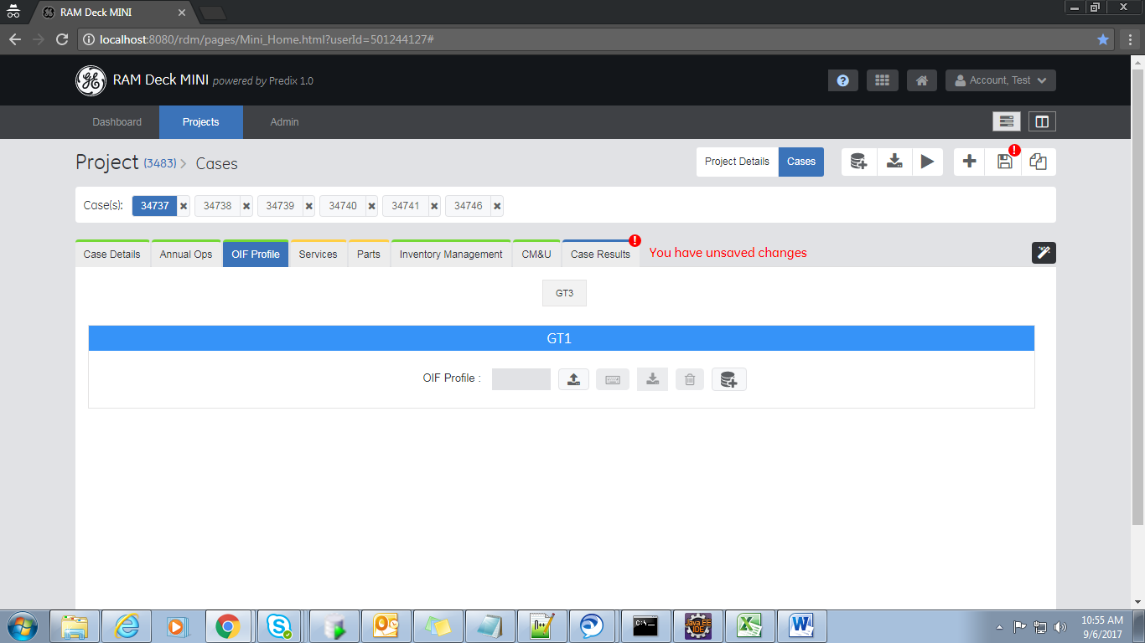

1. From there if I am trying to load a Oif profile from this the profile is getting loaded but the profile id is not getting reflected in annual ops tab.

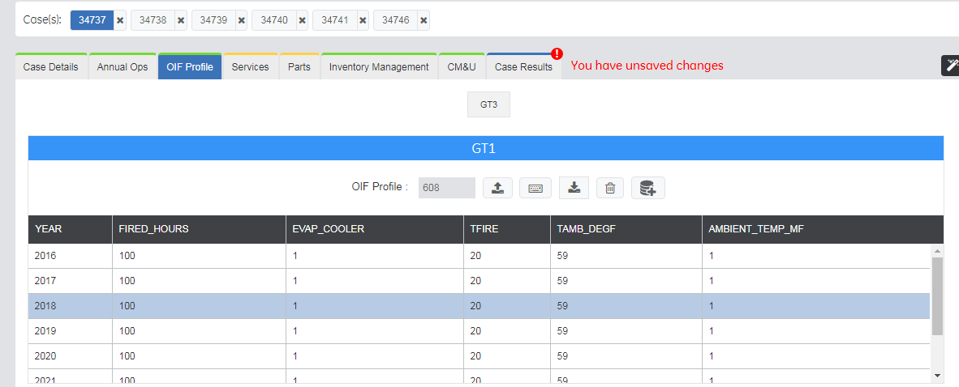

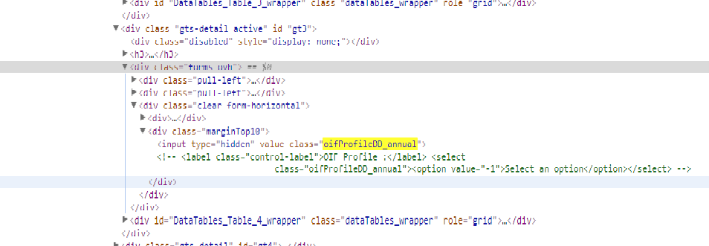

And if I try to toggle back to Oif profile Iam getting something like GTUndefined

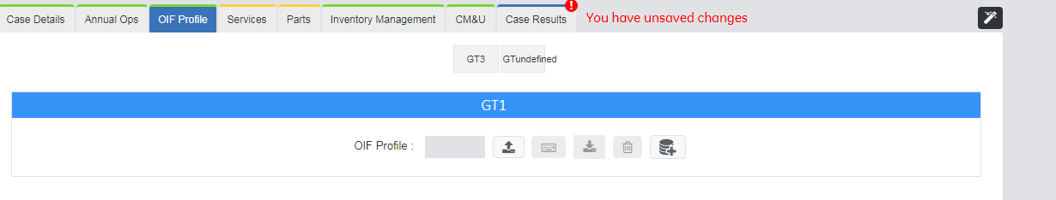

1. If the user is disabling all the GT from annual ops tab by keeping OIF profile toggle on and navigating to oif profile iam still able to see thee GT1 even though I have not selected any GT’s in annual ops.

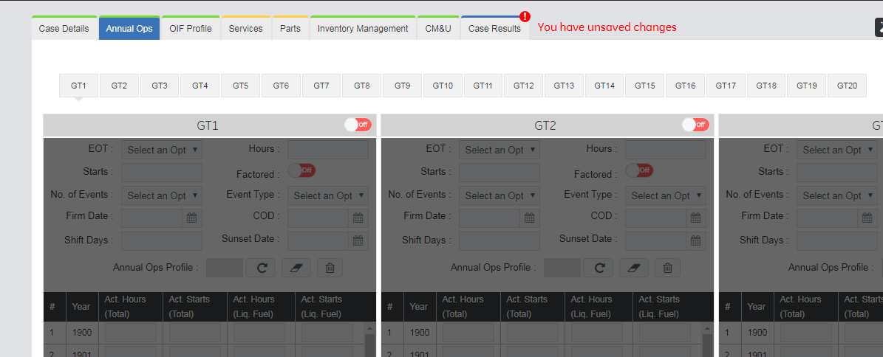

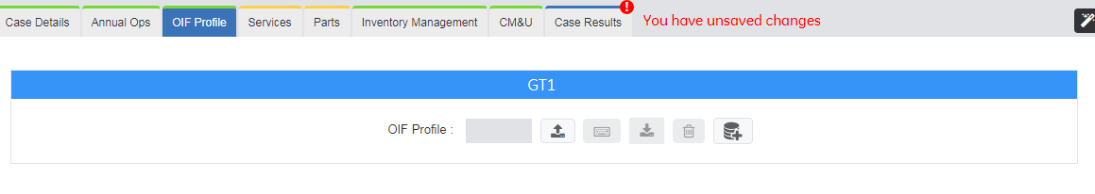

So if iam loading a profile from here and navigating to annual ops tab again and navigating back to oif profile iam getting GTUndefined in annual ops

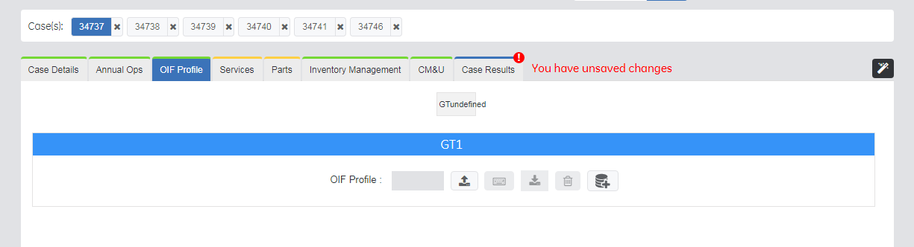

1. In Annual Ops tab if iam selecting a GT and loading a profile through oif profile and checking for its value in the hidden field iam able to get the value ie. oif profile id in hidden field

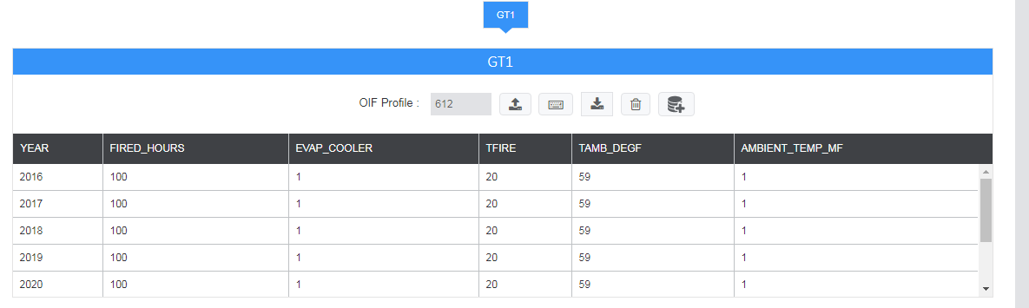

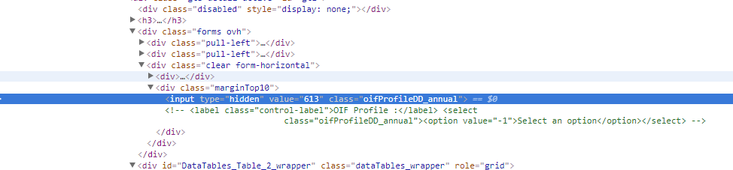

Again iam toggling back to oif profile and deleting the profile and in the annual ops tab the value is not set to null but its again displaying the old value

